Chapter 12 Notes

# LO12.1 Define aggregate demand and explain how its downward slope is the result of the real-balances effects, the interest-rate effect, and the foreign purchases effect

* Aggregate demand is a schedule or curve that shows the amount of a nation’s output (real GDP) that buyers collectively desire to purchase at each possible price level.
  + Buyers include the nation’s households, businesses, and government along with those located in other nations
* When the price level rises, the quantity of real GDP demanded decreases.
  + Vice versa
  + Negative / inverse relationship between economy’s overall price level and the amount of real GDP

## Aggregate Demand

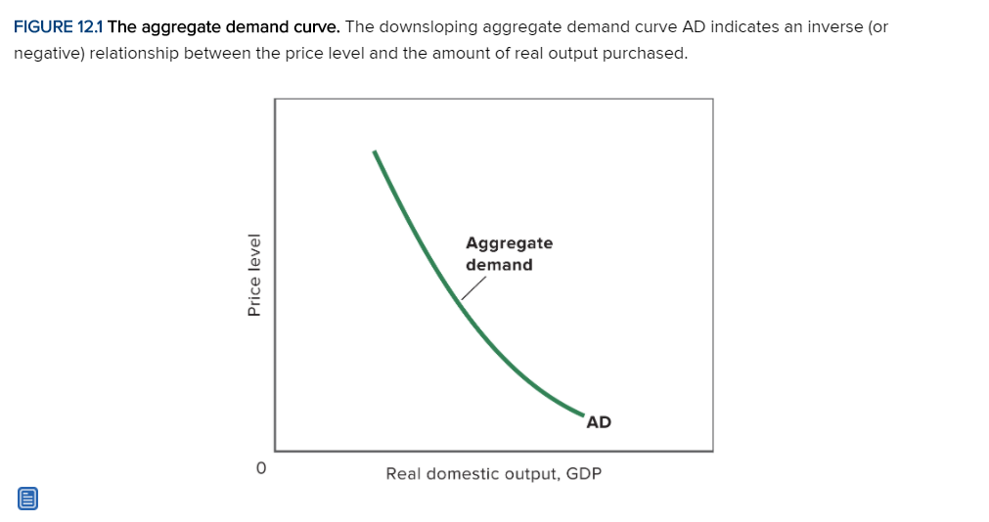

* Explanation is NOT the same as the explanation for why the demand for a single product slope downwards
  + When the price of an individual product falls, the consumer’s nominal income allows a larger purchase of the product 🡪 income effect
  + At the same time, the consumer will want to buy more of the individual product because it becomes less expensive relative to other goods, whose prices have not changed 🡪 substitution effect
* 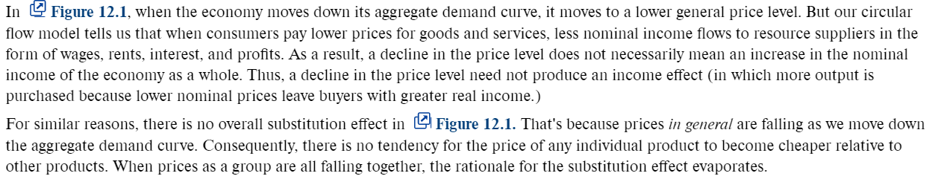Why don’t they work

## Real-Balances Effect

* Consumption varies inversely with changes in the price level
  + When the price level rises, real balances fall, purchasing power declines, and people demand less output
  + When the price level falls, real balances increase, purchasing power rises, and people demand more output.

## Interest-Rate Effect

* A higher price level increases the demand for money.
* Given the assumption that the supply of money is fixed, that increase in the demand for money will cause an increase in the interest rate
* Higher interest rate curtails investment spending and interest-sensitive consumption spending
* Hence, the amount of real output demanded will be reduced.

## Foreign Purchases Effect

* Increase in price levels results in a decrease in net exports.
* Foreigners would buy fewer domestic goods and domestic consumers would buy more foreign goods
* The strength of these tendencies will depend on whether exchange rate adjust quickly and completely

## Net

* A decline in price level
  + Increases consumption through the real-balances effect and interest-effect
  + Increases investment through the interest-rate effect
  + Raises export by increasing exports and decreasing imports through the foreign purchases effect

# LO12.2 Explain the factors that shift AD

* If one or more of those “other things” change, the entire aggregate demand curve will shift
* They are called the determinants of aggregate demand

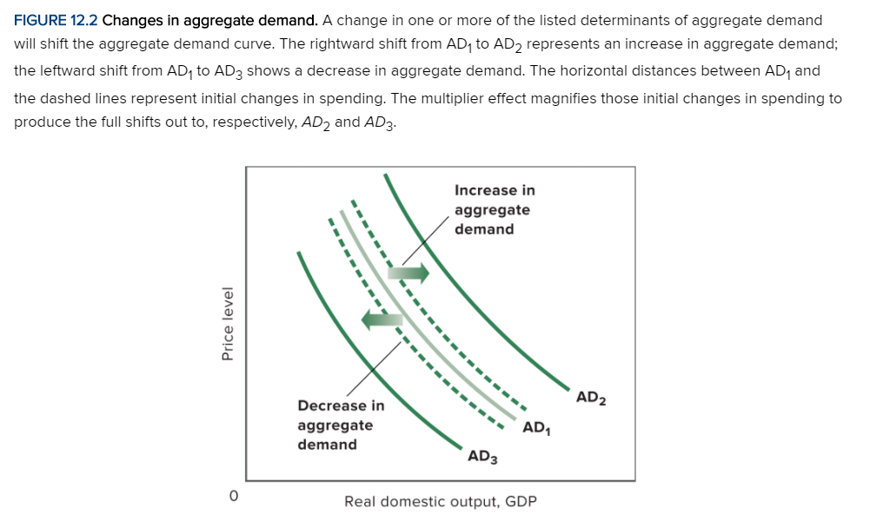

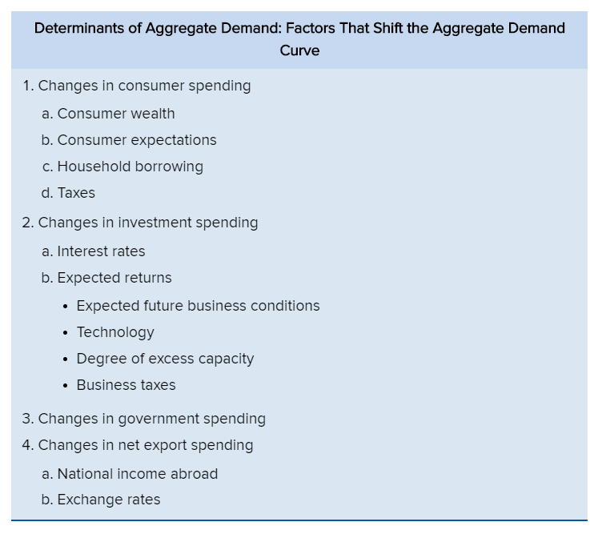

* Changes in aggregate demand can be broken into two stages:
  + A change in a determinant of aggregate demand that causes an initial change in the amount of real GDP demanded
* Compare the AD and the broken line
  + Broken line is immediate increase
  + AD line is after multiplier

## Consumer Spending

* Consumer wealth
  + Consumer wealth is the total dollar value of all assets owned by consumers less the dollar value of their liabilities (debt)
    - Assets include stocks, bonds and real estate
    - Liabilities include mortgages, student loans, credit card balances
  + Consumer wealth sometimes changes suddenly and unexpectedly due to surprising changes in asset values.
  + If the value of the assets increases, consumers will save less and spend more 🡪 AD shift to the right
  + Vice versa
  + Called wealth effect and reverse wealth effect respectively
* Household borrowing
  + Increased borrowing 🡪 increased current spending
  + Increase saving to service the debt
* Consumer Expectations
  + When people expect their future real incomes to rise, they tend to spend more of their current incomes
  + Vice versa
  + Surging inflation, future real incomes, etc. all contribute
* Personal taxes
  + Increase in taxes, reduces consumption
  + Reduction in taxes, increases consumption
  + Disposable income changes

## Investment Spending

* Real interest rates
  + Increase in real interest rates will raise borrowing costs, lower investment spending, and reduce aggregate demand
  + This is caused by a CHANGE in nation’s money supply
  + An increase in the money supply lowers the real interest rate, thereby increasing investment and aggregate demand.
  + A decrease in the money supply raises the real interest rate, reducing investment and decreasing aggregate demand
* Expected Returns
  + Higher expected rate of returns on investment projects increase the demand for capital goods and shift the aggregate demand curve to the right

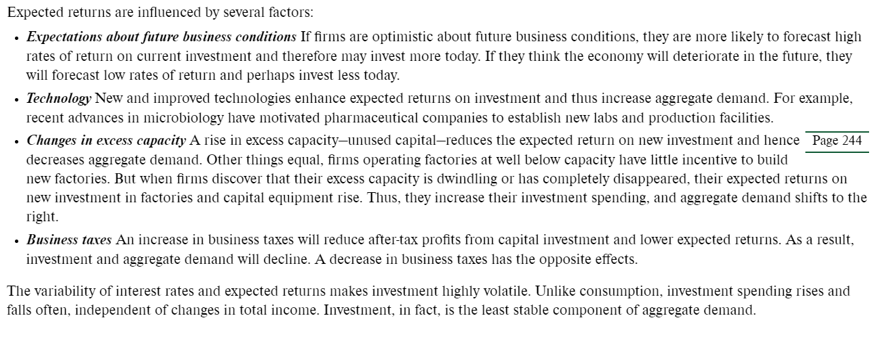

## Government Spending

* An increase in government purchases vs a decrease
  + Direct impact
* If, the tax collections and interest rates do not change as a result

## Net Export Spending

* National income abroad
  + Rising national income abroad encourages foreigners to buy more products, some of which are made domestically
  + Hence net exports rise
  + Vice versa

## Exchange rate

* Changes in the dollar’s exchange rate
* Suppose the dollar depreciates in terms of the euro
  + European consumers obtain more dollars with each euro
  + From the European perspective, domestic goods are now less expensive
* Increase net exports
* Increase AD
* Vice versa

# LO12.3 Define Aggregate Supply and explain how it differs in the immediate short run, the short run, and the long run

* Aggregate supply is a schedule or curve showing the relationship between a nation’s price level and the amount of real domestic output that firms produce
* The relationship varies depending on the time horizon and how quickly output prices and input prices can change:
  + Immediate short run
    - Input and output prices are fixed
  + Short run
    - Input prices are fixed but output prices can vary
  + Long run
    - Input prices and out prices can vary
* The relationship between the price level and total output is different in each of the three time horizons because input prices are stickier than output process
* Although both sets of prices become more flexible as time passes, output prices usually adjust more rapidly

## Aggregate Supply in the Immediate Short Run

* Lasts as long as BOTH input prices and output prices stay fixed
* Input and output prices are fixed due to contractual agreements
  + Labor contracts for months or years at a time (input price)
  + Firms set fixed prices for their customers and then agree to supply whatever quantity demanded results at those fixed prices (output price)
    - An appliance manufacturer sets its annual prices for refrigerators, stoves, and microwaves, it is obligated to supply as many appliances as customers want to buy at those prices.
* Hence, the immediate short run aggregate supply is a horizontal line
* Its horizontal shape implies that the total amount of output supplied in the economy depends directly on the volume of spending that results at price level P1.

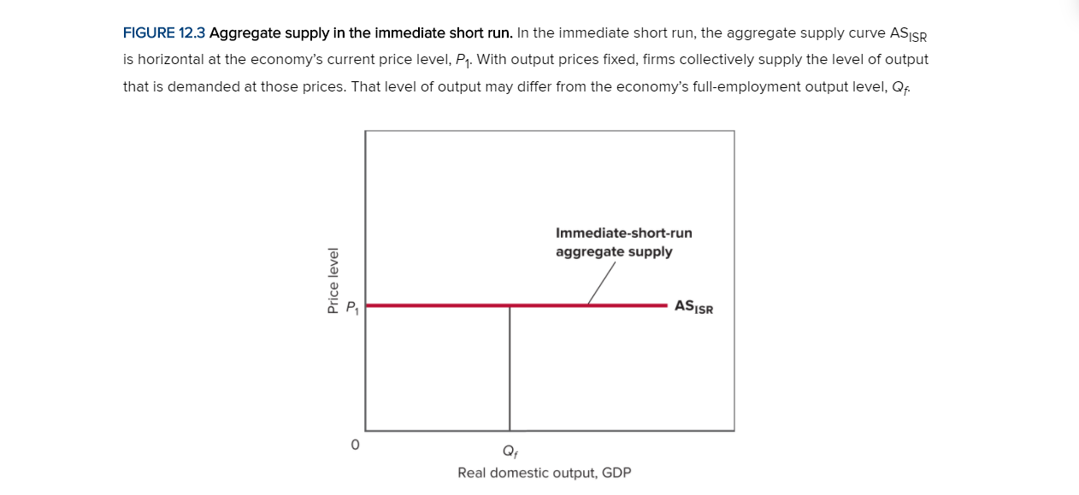

* Firms will only respond in this manner to changes in total spending only as long as output prices remain fixed

## Aggregate Supply in the Short Run

* The short run begins after the immediate short run
* Output prices are flexible, but input prices are either totally fixed or highly inflexible
* Some input prices are more flexible than others (e.g. Gasoline)
* The short-run aggregate supply curve slopes upward because with input prices fixed, changes in price level will raise or lower firms’ real profits

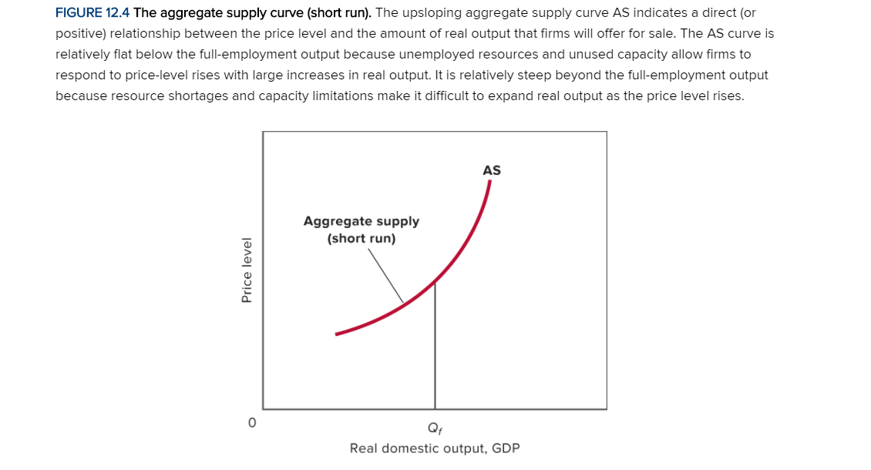

* There is a direct, or positive, relationship between the price level and real output
* Upward slope of the short-run aggregate supply curve is not constant
* It is flatter at outputs below the full-employment and steeper at outputs above it
  + Reason: lower per-unit production costs that underlie the short-run aggregate supply curve
  + The below explains it in detail

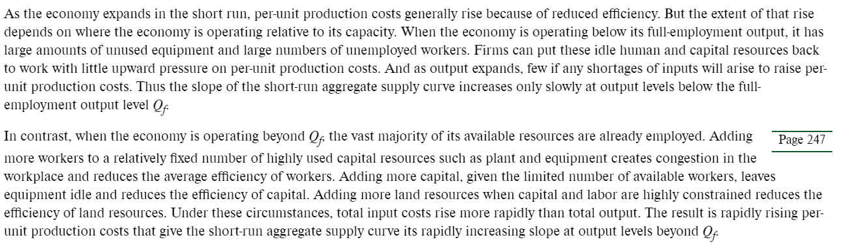

## Aggregate Supply in the Long Run

* Input prices and output prices are flexible
* Begins after the short run ends
* Wage rates are fully flexible too
* The long run aggregate supply curve is vertical at the economy’s full-employment output
* In the long run, when both input and output prices are flexible, profit levels always adjust to give firms exactly the right profit incentive to produce exactly the full-employment output level, Qf.

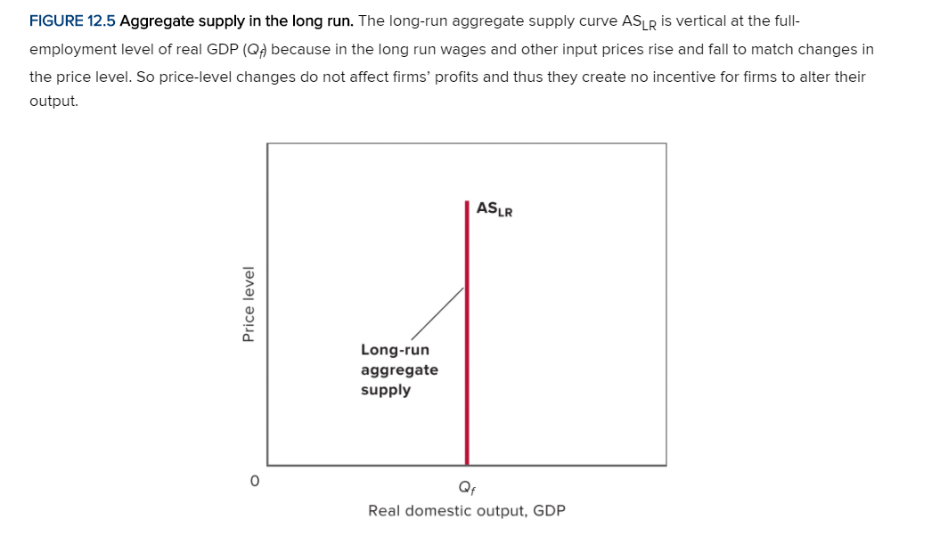

* Look at the explanation below. It explains why the long run aggregate supply is vertical

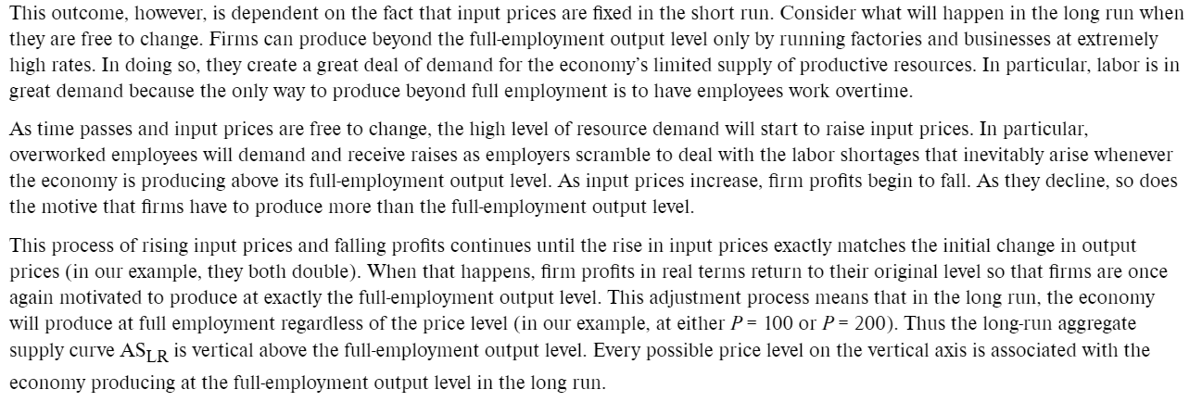

## Focusing on the Short Run

* Emphasizing on short run aggregate supply because real world economies typically manifest simultaneous changes in both their price levels and their levels of real output
* It is helpful when it comes to understanding business cycles and macroeconomic policy

# LO12.4 Explain the factors that shift AS

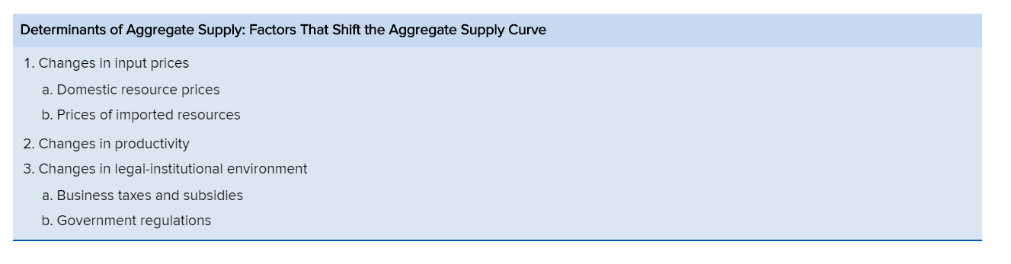

* Determinants of aggregate supply collectively position the aggregate supply curve and shift the curve when they change
* Changes in these determinants change per-unit production costs at each price level
* These affect profits, leading firms to alter the amount of output they are willing to produce at each price level

## Input Prices

* Domestic Resource Prices
  + Wages and salaries make up about 75% of all business costs
  + Examples:

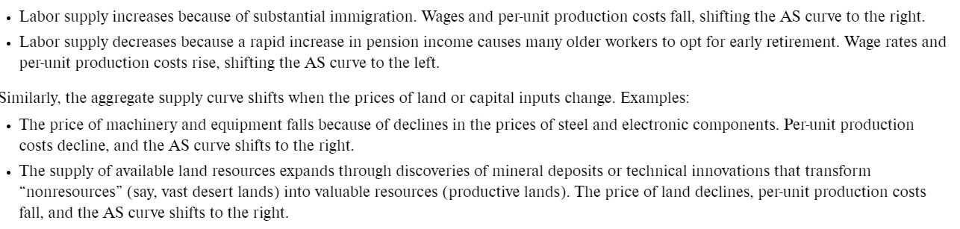

* + Similarly, the aggregate supply curve shifts when the prices of land or capital inputs change. Examples:



* Prices of imported resources
  + Increase in prices of imported resources will lower domestic profits
  + Vice versa
  + 1970s OPEC
  + Exchange rate fluctuations may also alter the price of imported resources
  + If the dollar appreciates, domestic producers will face a lower dollar price of imported resources 🡪 falling per-unit production costs
* Productivity
  + 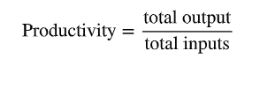Measures how much output can be produced from any given set of inputs
  + Higher productivity implies greater efficiency. An increase in productivity enables the economy to obtain more output from its limited resources
  + Example:

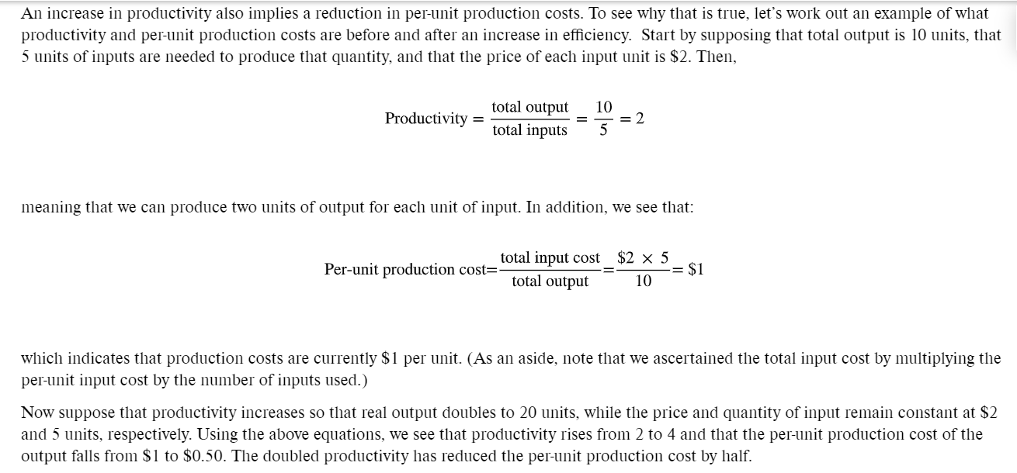

* + The main source of productivity advance is improved production technology
    - New plant and equipment that replaces old plant and equipment
  + Other sources of productivity increases are a better-educate and better-trained workforce, improved forms of business enterprise, and the reallocation of labor resources from lower productivity to higher-productivity uses.

## Legal-Institutional Environment

* Changes in Business taxes and subsidies
  + Higher business taxes, such as sales, excise, and payroll taxes, increase per-unit costs and reduce short-run aggregate supply. Higher business taxes shift aggregate supply to the left. Vice versa
  + A business subsidy, a payment or tax break by government to producers, lowers production costs and increases SRAS. Vice versa
* Government regulation
  + More regulation tens to increase per-unit production costs
  + Not very certain as to whether should have more or less regulation

# LO12.5 Explain how AD and AS determine an economy’s equilibrium price level and real GDP

* Equilibrium occurs at the price level that equalizes the amounts of real output demanded and supplied
* The intersection of the aggregate demand curve AD and the aggregate supply curve AS establishes the economy’s equilibrium price level and equilibrium real output

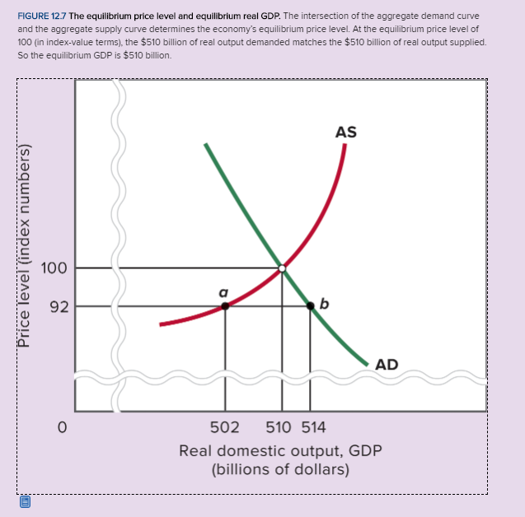

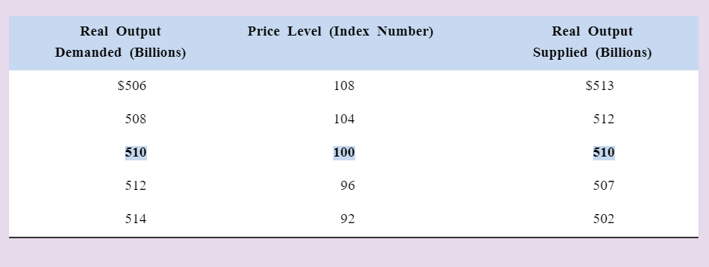

* Look at the graph for more information, less at the table

# LO12.6 Use the AD-AS model to explain demand-pull inflation, cost-push inflation and recession

## Increases in AD: Demand-Pull Inflation

* The increase in aggregate demand beyond full-employment output causes inflation
* This is demand-pull inflation because the price level is being pulled up by the increase in aggregate demand
* Increase in demand expands real output from full employment Qf to Q1. The distance between Q1 and Qf is a positive, or “inflationary” GDP gap.
* Actual GDP exceeds potential GDP

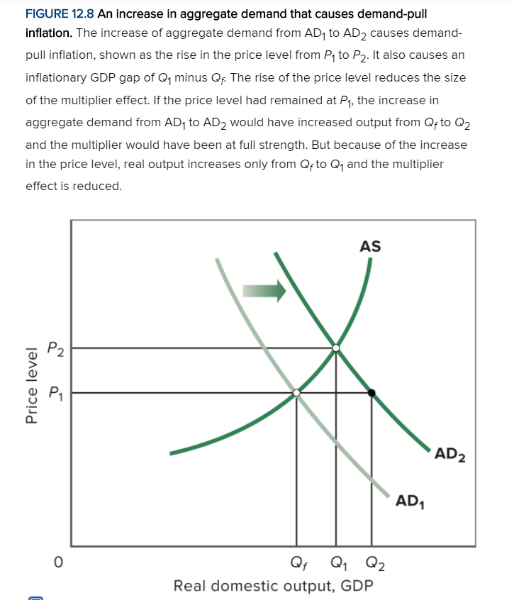

* Demand pull inflation occurred in the later 1960s in America
* The escalation of the war in Vietnam resulted in 40% increase in defense spending between 1965 and 1967 and another 15% increase in 1968
* The rise in government spending on top of an already growing economy, shifted the economy’s AD curve to the right, producing the worst inflation in two decades

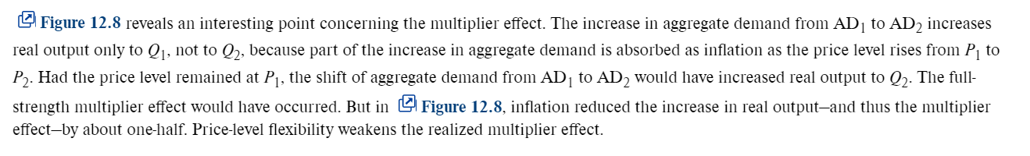

## Decreases in AD: Recession and Cyclical Unemployment

* In 2008, US investment spending greatly declined because of sharply lower expected returns on investment
* These lower expectations resulted from the prospect of poor future business conditions and high degrees of unused production capacity.

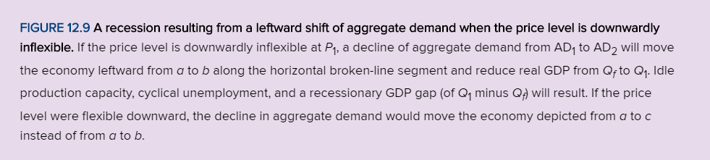

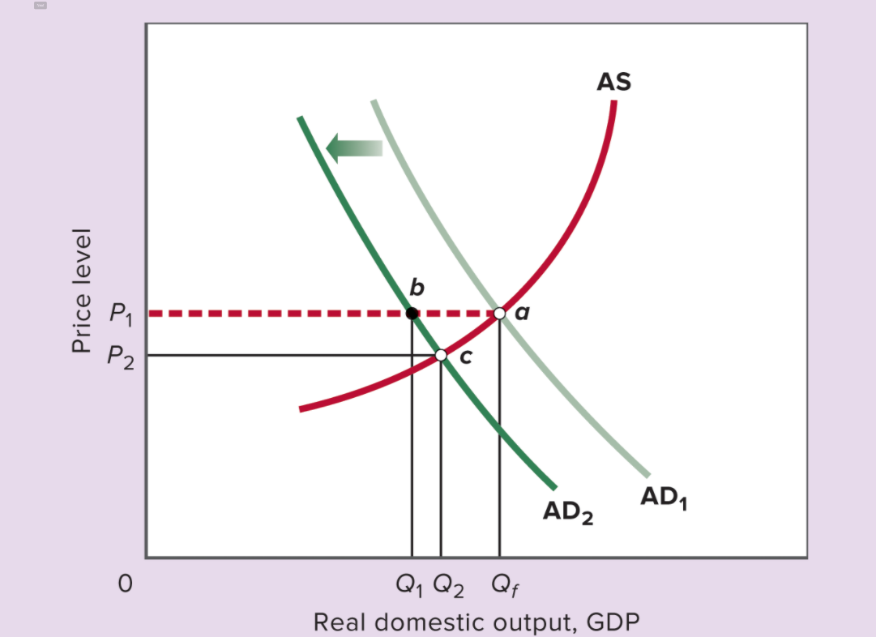

* If the prices were flexible downwards, both deflation and recession could happen
* Without a fall in price level, the multiplier is at full strength
* Note: this full-strength multiplier would also apply for an increase in AD

## Decreases in AS: Cost-Push Inflation

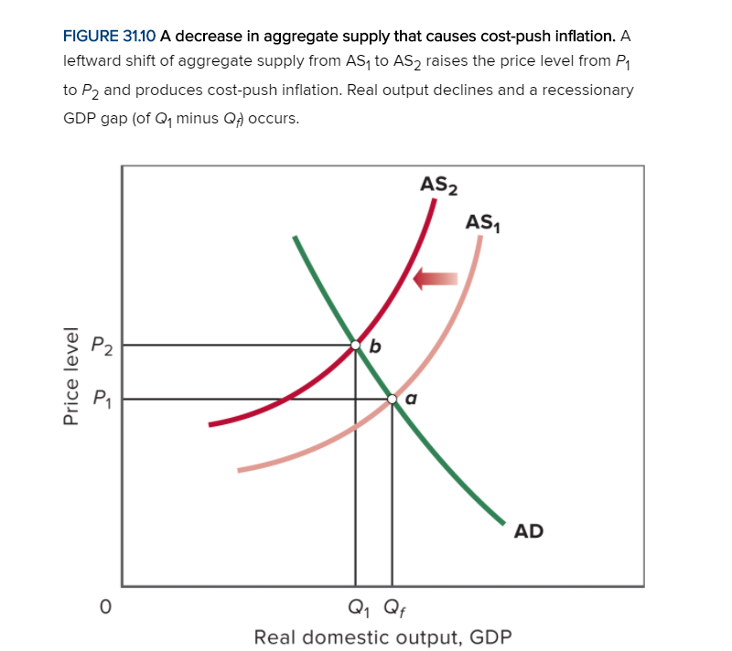

* The effects of the leftward shift in aggregate supply are doubly bad.
* Along with rising price level and cost-push inflation, a recession (and negative GDP gap) occurs.

## Increases in AS: Full employment with Price-level Stability

